**Edge Computing Laboratory**

**Lab Assignment 2**

**Name:** Dhairya Patil

**Class:** TY AIEC Batch C

**Enrollment No:** MITU22BTCS0256

**Roll No:**2223929

**Title:** Real-Time Temperature and Humidity Monitoring using DHT11 Sensor and Flask.

**Objective:** To interface a DHT11 sensor with a Raspberry Pi and create a web application using Flask to display real-time temperature and humidity data.

Theory:

The DHT11 is a low-cost digital sensor that measures temperature and humidity in the environment. It communicates via a single-wire serial interface, making it easy to interface with microcontrollers like the Raspberry Pi. The sensor provides 9-bit humidity and 8-bit temperature readings with an accuracy of ±2°C and ±5% RH.

To display this data in real-time, a Flask web application is used. Flask is a lightweight Python web framework that allows us to create a local web server on the Raspberry Pi. The sensor data is read periodically using Python (via the Adafruit_DHT library) and sent to a webpage using Flask’s Jinja2 templating engine. This enables users to monitor temperature and humidity remotely through a browser.

The system works in three main steps:

* Data Acquisition – The Raspberry Pi reads sensor data from the DHT11.
* Data Processing – Python processes and formats the readings.
* Web Visualization – Flask serves the data to a webpage, which refreshes at intervals (using auto-refresh or AJAX).

**Python Code:**

import Adafruit_DHT #importing Adafruit_DHT sensor liabrary

import time #importing Time liabrary

import RPi.GPIO as GPIO #importing General purpose Input Output pins of Rasberry Pi

GPIO.setmode(GPIO.BCM) #setting Connection Mode of Circuit as BCM (not Board)

sensor = Adafruit_DHT.DHT11 #declaring DHT sensor

pin = 23 #using/declaring BCM pin number 23

while True:

humidity.temperature = Adafruit_DHT.read_retry(sensor,pin)

if humidity is None and temperature is None:

print("Failed to get reading. Try Again!")

else:

print("Temp={0:0.1f}*C Humidity={0:0.2f}%".format(temperature, humidity))

time.sleep(1)

**Output:**

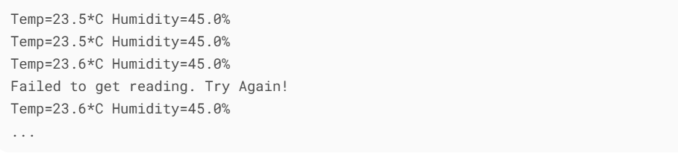

**Conclusion:**

In this experiment, we successfully:

* Interfaced a DHT11 sensor with a Raspberry Pi.
* Built a Flask web application to serve real-time sensor data.
* Utilized AJAX to dynamically update webpage content without refreshing the page.